R703 Register No:…………………...
Name:……………………...…..

RAJAGIRI SCHOOL OF ENGINEERING AND TECHNOLOGY

B.TECH DEGREE FIRST INTERNAL EXAMINATION, August 2008

Seventh Semester Computer Science and Engineering
Theory of computation

Time: 2 hours Maximum Marks: 50

Answer all questions

Part A

- Show that the set of rational numbers is countable.
- If A, B are two finite sets and |A| > |B|, prove that there is no one to one function from A to B. (2*3=6 Marks)

Part B

- Check whether the following relations are equivalent or partial ordered (i) a≤b (ii) a≡b%n, where a,b,n N. Explain.
- For any three sets A, B and C, show that (A-B)-C = (A-C)-(B-C).
- Convert the following NFA to DFA, where Q={0,1,2,3,4} and ∑={a,b}.
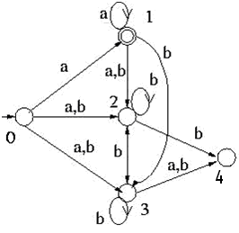
(3*4=12 Marks)

Part C

- State and illustrate Diagonalization principle. Using this, show that the power set of N is uncountable.
- If L1={010,101,11} L2={111,101,100}, find the following (i) L1* (ii) L2⁺ (iii) L^{R} (iv) L^{C} (v) L1-L2 (vi) L1L2 (vii) L1-L2 (viii) L1L2
- Design the DFA for the following. Include the possible dead states (i) L={w {a,b}* : w begins with a, n_{a}=1, n_{b}%3>0} (ii) L={w {a,b}* : w having length at most 5}
- Differentiate between DFA and NFA. Minimize the following DFA.
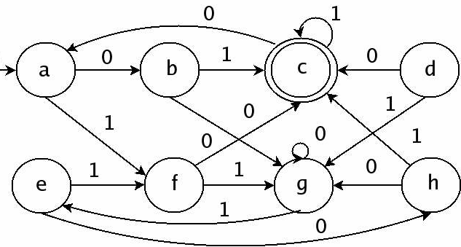
(4*8=32 Marks)

