2d Transformations

Aim

Write a program to do 2d transformations on a polygon. Transformations like translation, scaling, rotations etc

Transformations are a fundamental part of computer graphics. Transformations are used to position objects, to shape objects, to change viewing positions, and even to change how something is viewed (e.g. the type of perspective that is used).
There are 4 main types of transformations that one can perform in 2 dimensions:
- translations
- scaling
- rotation
- shearing
These basic transformations can also be combined to obtain more complex transformations. In order to make the representation of these complex transformations easier to understand and more efficient, we introduce the idea of homogeneous coordinates.

Representation of Points/Objects

A point p in 2D is represented as a pair of numbers: p= (x, y) where x is the x-coordinate of the point p and y is the y-coordinate of p . 2D objects are often represented as a set of points (vertices), {p₁,p₂,...,p_{n}}, and an associated set of edges {e₁,e₂,...,e_{m}}. An edge is defined as a pair of points e = {p_{i},p_{j}}. What are the points and edges of the triangle below?
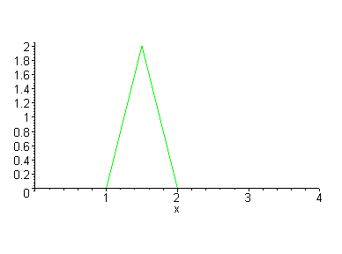
We can also write points in vector/matrix notation as
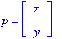
Translations
Assume you are given a point at (x,y)=(2,1). Where will the point be if you move it 3 units to the right and 1 unit up? Ans: (x',y') = (5,2). How was this obtained? - (x',y') = (x+3,y+1). That is, to move a point by some amount dx to the right and dy up, you must add dx to the x-coordinate and add dy to the y-coordinate.
What was the required transformation to move the green triangle to the red triangle? Here the green triangle is represented by 3 points
triangle = { p1=(1,0), p2=(2,0), p3=(1.5,2) }
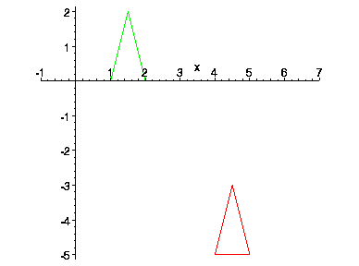
What are the points and edges in this picture of a house? What are the transformation is required to move this house so that the peak of the roof is at the origin? What is required to move the house as shown in animation?
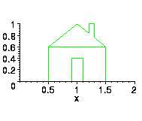
Matrix/Vector Representation of Translations
A translation can also be represented by a pair of numbers, t=(t_{x},t_{y}) where t_{x} is the change in the x-coordinate and t_{y} is the change in y coordinate. To translate the point p by t, we simply add to obtain the new (translated) point q = p + t.
q = p + t = 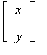+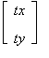 = 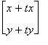
Scaling

Suppose we want to double the size of a 2-D object. What do we mean by double? Double in size, width only, height only, along some line only? When we talk about scaling we usually mean some amount of scaling along each dimension. That is, we must specify how much to change the size along each dimension. Below we see a triangle and a house that have been doubled in both width and height (note, the area is more than doubled).
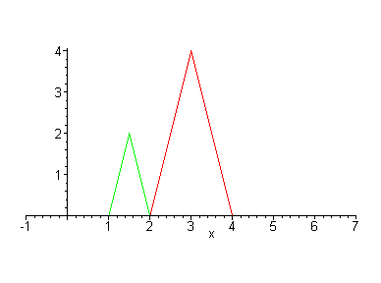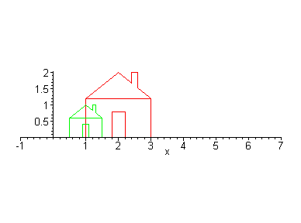
The scaling for the x dimension does not have to be the same as the y dimension. If these are different, then the object is distorted. What is the scaling in each dimension of the pictures below?
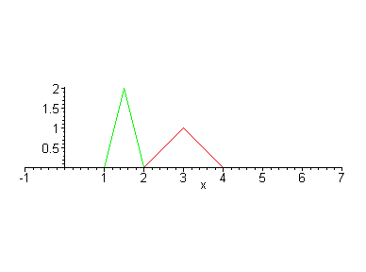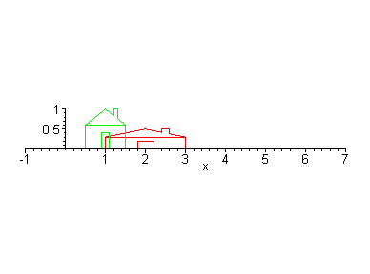
And if we double the size, where is the resulting object? In the pictures above, the scaled object is always shifted to the right. This is because it is scaled with respect to the origin. That is, the point at the origin is left fixed. Thus scaling by more than 1 moves the object away from the origin and scaling of less than 1 moves the object toward the origin. This can be seen in the animation below.
This is because of how basic scaling is done. The above objects have been scaled simply by multiplying each of its points by the appropriate scaling factor. For example, the point p=(1.5,2) has been scaled by 2 along x and .5 along y. Thus, the new point is
q = (2*1.5,.5*2) = (1,1).
Matrix/Vector Representation of Translations
Scaling transformations are represented by matrices. For example, the above scaling of 2 and .5 is represented as a matrix:
scale matrix: s = 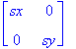= 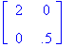
new point: q = s*p = 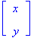= 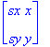
Scaling about a Particular Point
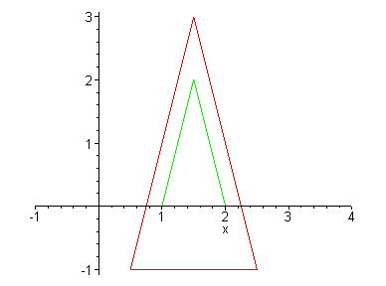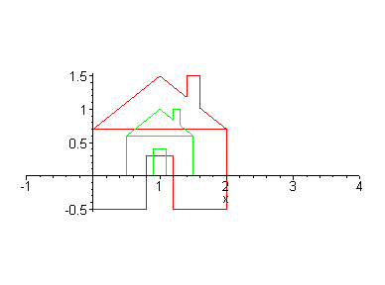

Rotation
Below, we see objects that have been rotate by 25 degrees.
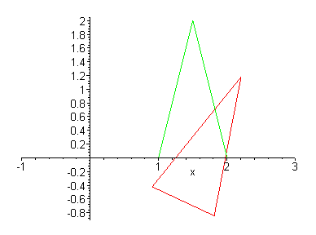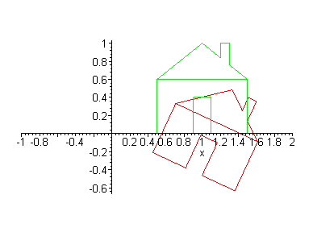
Again, we see that basic rotations are with respect to the origin:

Algorithm
Drawpoly (corners, n)
for I=1 to n-1
drawline(corner[I].x, corner[I].y, corner[I+1].x, corner[I+1].y)
drawline(corner[n].x, corner[n].y, corner[0].x, corner[0].y) //drawing line from last corner point to first corner point
end drawpoly

Algorithm
Translate (corners, n, xt, yt)
Define array temp
For I=1 to n
temp[I].x= Corner[I].x+Xt
temp[I].y =Corner[I].y+Yt
Drawpoly (corners, n)
Drawpoly (temp, n)
End translate

Algorithm
scale (corners, n, xt, yt)
Define array temp
For I=1 to n
temp[I].x= Corner[I].x*Xt
temp[I].y =Corner[I].y*Yt
Drawpoly (corners, n)
Drawpoly (temp, n)
End translate

Algorithm
rotate (corners, n, theta)
Define array temp
For I=1 to n
temp[I].x= Corner[I].x*cos (theta) - Corner[I].y *sin (theta)
temp[I].y = Corner[I].x* sin (theta) + Corner[I].y * cos (theta)
Drawpoly (corners, n)
Drawpoly (temp, n)
End translate

Algorithm
Main
Read the edges of the polygon
Store all vertex of the polygon in array corner
Read the operation
Case translation
Read xt and yt
Translate (corners, n, xt, yt)
Case scaling
Read xs and ys
scale (corners, n, xs, ys)
Case rotation
Read theta
rotate (corners, n, theta)
end main

Testing

number of edges 3
100,100
300,100
200,150
scale this triangle by 2
translate by 50
rotate by 45

