TOC Assignment 2

1. Design a FA which accepts set of strings containing four l's in every string over alphabet ∑={0, 1}.

Solution. DFA should accepts the strings 1111, 0101011, 0110110000
Let DFA be M = (Q,∑,∂, q0 ,F)
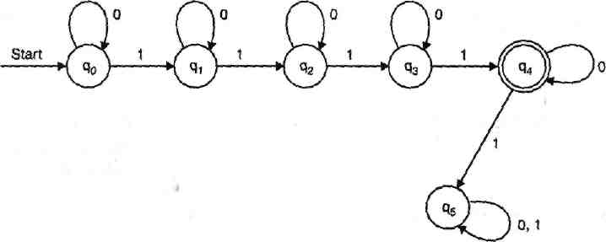
F = {q4}
From q_{Q} to q₄ transitions four l's are already there and q₄ is final state so 1 from q₄ should go on a trap path, that is why q₅ is there so q₅ is called trap or dead state.
"Dead states are those non final states which transits in itself for all the input symbol. So q₅ is the example of dead state."

2. Design a FA that accepts strings containing exactly one 1 over alphabet (0, 1}

Solution : String set according to the problem, which is accepted by the FA is like
1, 0001, 01000, 0001000,
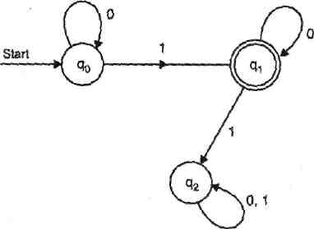
So clearly starting state to final state there is only one transition of 1. Let suppose DFA be
M = (Q, ∑, ∂ , q_{Q}, F)
Q = {q0, q1, q2}
F = {q1}
q₂ is the dead state.

3. Design a FA which accepts the language
L = {w € (0, l)*/second symbol of w is '0' and fourth input is 1}.

Solution: Solution. So after analysing the problem we find that every string of the language is like
0001, 1011, 10110000,
Let FA is M = (Q, ∑, ,∂, q0, F)

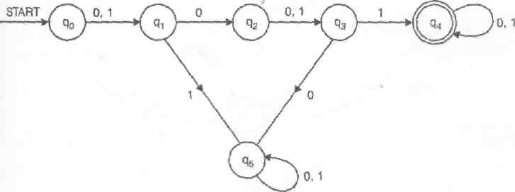
Q = {q0. q1, q2, q3, q4,q5}

q5 is dead state.

4. Find a regular expression corresponding to the language of all strings over the alphabet { a, b } that do not end with ab

Solution: Any string in a language over { a , b } must end in a or b. Hence if a string does not end with ab then it ends with a or if it ends with b the last b must be preceded by a symbol b. Since it can have any string in front of the last a or bb, ( a + b )*( a + bb ) is a regular expression for the language.

5. Find a regular expression corresponding to the language of all strings over the alphabet { a, b } that contain no more than one occurence of the string aa.

Solution: If there is one substring aa in a string of the language, then that aa can be followed by any number of b. If an a comes after that aa, then that a must be preceded by b because otherwise there are two occurences of aa. Hence any string that follows aa is represented by ( b + ba )*. On the other hand if an a precedes the aa, then it must be followed by b. Hence a string preceding the aa can be represented by ( b + ab )*. Hence if a string of the language contains aa then it corresponds to the regular expression ( b + ab )*aa( b + ba )* .
If there is no aa but at least one a exists in a string of the language, then applying the same argument as for aa to a, ( b + ab )*a( b + ba )* is obtained as a regular expression corresponding to such strings.
If there may not be any a in a string of the language, then applying the same argument as for aa to , ( b + ab )*( b + ba )* is obtained as a regular expression corresponding to such strings.
Altogether ( b + ab )*( + a + aa )( b + ba )* is a regular expression for the language.

6. Find a regular expression corresponding to the language of strings of even lengths over the alphabet of { a, b }.

Solution: Since any string of even length can be expressed as the concatenation of strings of length 2 and since the strings of length 2 are aa, ab, ba, bb, a regular expression corresponding to the language is ( aa + ab + ba + bb )*. Note that 0 is an even number. Hence the string is in this language.

7. Describe as simply as possible in English the language corresponding to the regular expression a*b(a*ba*b)*a*

Solution: A string in the language can start and end with a or b, it has at least one b, and after the first b all the b's in the string appear in pairs. Any numbe of a's can appear any place in the string. Thus simply put, it is the set of strings over the alphabet { a, b } that contain an odd number of b's

8. Describe as simply as possible in English the language corresponding to the regular expression (( a + b )³)*( + a + b )

Solution: (( a + b )³) represents the strings of length 3. Hence (( a + b )³)* represents the strings of length a multiple of 3. Since (( a + b )³)*( a + b ) represents the strings of length 3n + 1, where n is a natural number, the given regular expression represents the strings of length 3n and 3n + 1, where n is a natural number.

9. Describe as simply as possible in English the language corresponding to the regular expression ( b + ab )*( a + ab )*.

Solution: ( b + ab )* represents strings which do not contain any substring aa and which end in b, and ( a + ab )* represents strings which do not contain any substring bb. Hence altogether it represents any string consisting of a substring with no aa followed by one b followed by a substring with no bb.
10. What is the language accepted by the DFA given below.
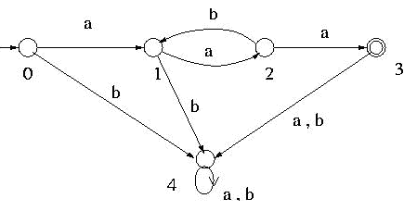

Solution: This DFA has a cycle: 1 - 2 - 1 and it can go through this cycle any number of times by reading substring ab repeatedly. To find the language it accepts, first from the initial state go to state 1 by reading one a. Then from state 1 go through the cycle 1 - 2 - 1 any number of times by reading substring ab any number of times to come back to state 1. This is represented by (ab)*. Then from state 1 go to state 2 and then to state 3 by reading aa. Thus a string that is accepted by this DFA can be represented by a(ab)*aa .

11. What is the language accepted by the DFA given below.

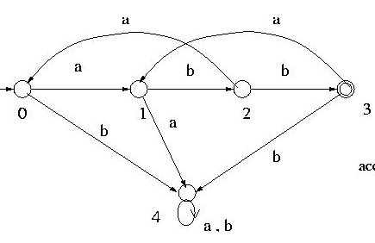

Solution: This DFA has two cycles: 1 - 2 - 0 - 1 and 1 - 2 - 3 - 1.
To find the language accepted by this DFA, first from state 0 go to state 1 by reading a ( any other state which is common to these cycles such as state 2 can also be used instead of state 1 ). Then from state 1 go through the two cycles 1 - 2 - 0 - 1 and 1 - 2 - 3 - 1 any number of times in any order by reading substrings baa and bba, respectively. At this point a substring a( baa + bba )* will have been read. Then go from state 1 to state 2 and then to state 3 by reading bb. Thus altogether a( baa + bba )*bb will have been read when state 3 is reached from state 0.

12. What is the language accepted by the DFA given below.
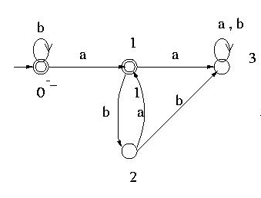
This DFA has two accepting states: 0 and 1. Thus the language that is accepted by this DFA is the union of the language accepted at state 0 and the one accepted at state 1. The language accepted at state 0 is b* . To find the language accepted at state 1, first at state 0 read any number of b's. Then go to state 1 by reading one a. At this point (b*a) will have been read. At state 1 go through the cycle 1 - 2 - 1 any number of times by reading substring ba repeatedly. Thus the language accepted at state 1 is b*a(ba)*
Language is : b*+b*a(ba)*

13. Prove that Language L = {a^{n}b^{n} for n = 0, 1, 2, 3, ... } is not regular.

Solution. Let us see how we could apply the pumping lemma directly to this case.
The pumping lemma says that there must be strings x, y and z such that all words of the form xy^{n}z are in L.
How do we break this into three pieces x, y and z ?
Case 1. If middle part y is made off entirely of a's, as
x aaaa ... z
How if we pump it as xyyz, xyyyz then number of a's increases, but in language L = {a^{n}b^{n} for n = 0, 1, 2, 3, ...} a's and b's are equal so it is not allowed.
case2. If middle part y is made off entirely of b's as
x bbbbb ... z
For the same reason, it is also not allowed.
Case 3. y part is made of some positive number of a's and some positive number of b's. This would mean that y certain the substring ab.
x ... aaaaabbbbb ... z
Then xyyz would have two copies of the substring ab. But every word in L contains substring ab exactly once. Therefore xyyz cannot be a word in L.
This proves that the pumping lemma cannot apply to L and therefore L is not regular
14. Prove that L = {a^{n}b a^{n} for n = 0, 1, 2, ...} is not regular.

Solution. If this language were regular then there would exist three strings x, y and z such that xyz and xyyz were both words in this language. We can show that this is impossible.
Observation 1. If the y string contained the b, then xyyz would contain two b's which no words in this language can have.
Observation 2. If the y string is all a's then, the b in the middle of the word xyz is in the x-side or z-side. In either case, xyyz has increased the number of a's either infront of the b or after b, but not both.
Conclusion. Therefore, xyyz does not have its b in the middle and is not in the form a^{n}ba^{n} This language cannot be pumped and is therefore not regular.

15. Prove that I = {a"b" ab^{n+1} for n = 1, 2, 3, ...} is not regular

Solution. We are going to show that this language too is not regular by j showing that if xyz is in this language for any three strings x, y and z, then xyyz is not in this language:
Observation 1. For every word in this language, if we know the total number of a's, we can calculate the exact number of b's (twice the total number of a's ~ 1).
And conversely, if we know the total number of b's, we can uniquely calculate the number of a's (add 1 and divide by 2). So no two different words have the same number of a's and b's.
Observation 2. All words in this language have exactly two substrings two substrings equal to ab and one equal to ba.
Observation 3. If xyz and xyyz are both in this language, then y cannot contain either substring ab or the substring ba because then xyyz would have too many.
Conclusion 1. It must be a solid dump of a's or solid dump of b's.
Conclusion 2. If y is solid a's, then xyz and xyyz are different words with same total b's, violating observation 1. If y is solid b's, then xyz and xyyz are different words with the same number of a's violating observation 1.
Conclusion 3. It is impossible for both xyz and xyyz to be in this language for any string x, y and z. Therefore, the language is unpumpable and not regular.

